**PRACTICAL 4 part 2**

**AIM:.**

**Create your Portfolio using HTML and CSS Tags**

**DESCRIPTION:**

<SCRIPT> TAG🡪 it is used to make use of javascript code in one file of index.html file

**Output:**



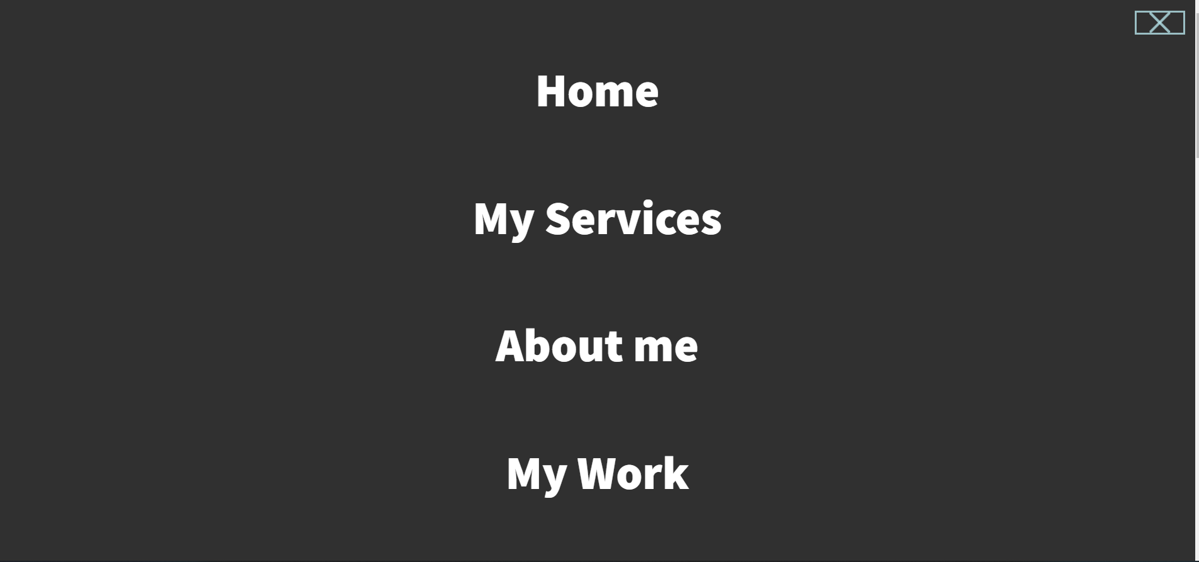



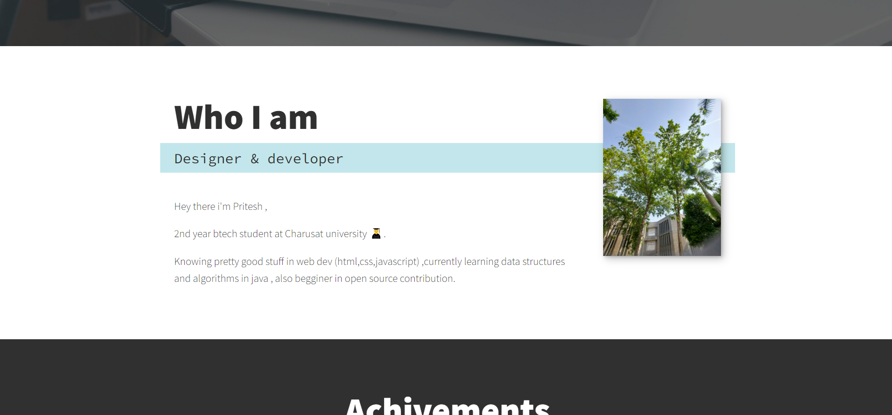







**CONCLUSION:**

Made a personal portfolio website using html tags, css, some of the classes from fontawsome css and javascript to make animations in the pages.